AM000-Asia-Japan-Edo-Mirror-Eight Arc-Bronze

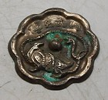

[Silver Plated Japanese Bronze Mirror - Oriental Creature ...](http://www.ebay.com/itm/320895824670?ssPageName=STRK:MEWNX:IT&_trksid=p3984.m1439.l2649) (320895824670)

Sale date: 05/07/12

Tracking number: --

GBP 12.99  
  
$20.53

See description

**Paid with PayPal on May 08, 2012.**

**Shipped 05/08/12**